Currency Exchange Application Documentation
Prepared by Dennis Njenga
For KOKO Networks Limited.
Overview
A Python-Flask Application that implements a currency exchange function using a currency conversion API that updates regularly.
Functional Attributes
1. The application intergrates a third party currency conversion service.
2. Creation of user accounts is enabled with a User Interface and comprises:
a. Login/Sign-up
b. Wallet
c. Profile of user with profile photo, default currency of user which are both editable from the UI.
d. Credit and Debit functions using any currency and amount with automatic conversion depending on default currencies
e. Transfer money between users.
Technical Requirements
1. Application uses git to do progressive commits.
2. Uses a dynamic application architecture, pattern, models and quality.
3. Includes test cases.
4. Includes a README file with steps to preparation, installations and functionality of the application.

Preparation
mkdir currency-exchange
Git
git init
touch .gitignore
Installations
pip install virtualenv
Create Virtual Environment called ‘virtual’: virtualenv virtual
Activate Virtual Environment: source virtual/bin/activate
Install Flask: pip install flask
Install Requests: pip install requests
Bootstrap: pip install flask-bootstrap
Forms: pip install flask-wtf
Flash Script: pip install flash-script
Fonts: pip install Flask-FontAwesome
LogIn: pip install flask-login
Werkzeug: pip install -U Werkzeug==0.16.0
Database Installations: pip install flask-SQLAlchemy
pip install psycopg2
Database Migrations: pip install Flask-Migrate==2.7.0
python3 manage.py db init
python3 manage.py db migrate -m "Initial Migration"
python3 manage.py db upgrade
Enable easy run: chmod a+x start.sh
./start.sh
Development: Currency Exchange Function
Test Installation and the Virtual Environment
from flask import Flask, render_template, request
import requests
app = Flask(__name__)

@app.route("/")
def index():
return "Hello World"

if __name__ == "__main__":
app.run(debug=True)
API
The API chosen for this project is the Free Currency Converter. The API provider offers free web services for developers to convert one currency to another. Currency values are updated every 60 minutes but on the free plan may experience some downtime occasionally.
Test API functionality.
from flask import Flask, render_template, request
import requests
import os

app = Flask(__name__)

@app.route("/")
def index():
API = os.environ.get("CURR_API")
fromCurr = "USD"
toCurr = "KES"
url = f"https://free.currconv.com/api/v7/convert?q={fromCurr}_{toCurr}&compact=ultra&apiKey={API}"
rates = requests.get(url).json()
return rates

if __name__ == "__main__":
app.run(debug=True)
Input/Output Forms
Using Bootstap, create a input – output form to take in the currency data as input, process and provide the output as the exchange rate between two different currencies. For example USD to KES.
{%extends "base.html"%}
{%block body%}
<form action="{{url_for('index')}}" method="post">
<div class="form-group">
<div class="form-group col-md-4">
<label for="fromCurr">From:</label>
<select id="fromCurr" class="form-control" name="fromCurr">
<option selected>Choose...</option>
<option></option>
</select>
</div>
</div>
<div class="form-group">
<div class="form-group col-md-4">
<label for="toCurr">To:</label>
<select id="toCurr" class="form-control" name="toCurr">
<option selected>Choose...</option>
<option></option>
</select>
</div>
</div>
<div class="form-group">
<input type="text" class="form-control" value="" disabled>
</div>
<button type="submit" class="btn btn-primary">Get Exchange Rates</button>
</form>
{%endblock%}

Retrieve Currency Data from API and format it in a way that will be utilized by the application.
if __name__ == "__main__":
for data in requests.get("https://free.currconv.com/api/v7/currencies?apiKey={API}").json()["results"]:
print(data)
Enable conversion rate from any known currency to any other know currency by display the exchange rate/ For example From USD to KES the exchange rate displayed is 107.7949 KES.
@app.route("/", methods=["POST", "GET"])
def index():
if request.method == "POST":
API = os.environ.get("CURR_API")
fromCurr = request.form.get('fromCurr')
toCurr = request.form.get('toCurr')
if fromCurr and toCurr:
try:
url = f"https://free.currconv.com/api/v7/convert?q={fromCurr}_{toCurr}&compact=ultra&apiKey={API}
rates = requests.get(url).json()[f'{fromCurr}_{toCurr}']
return render_template('index.html', currency=currencys, result=f"{rates} {toCurr}")
except:
flash("Error Occured", 'danger')
return redirect(url_for('index'))
else:
flash("Error Occured", 'danger')
return redirect(url_for('index'))

return render_template('index.html', currency=currencys)
User Authentication
Authentication comprises a log-in, signup, profile and edit profile function that includes the option to update a profile picture and select a default currency. Every user starts with a KES 1000 balance converted into their default currency.
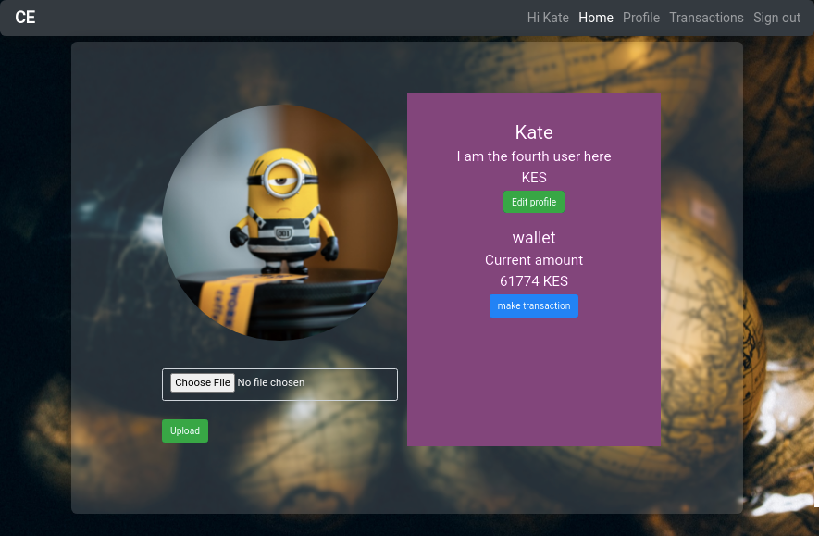
Edit Profile
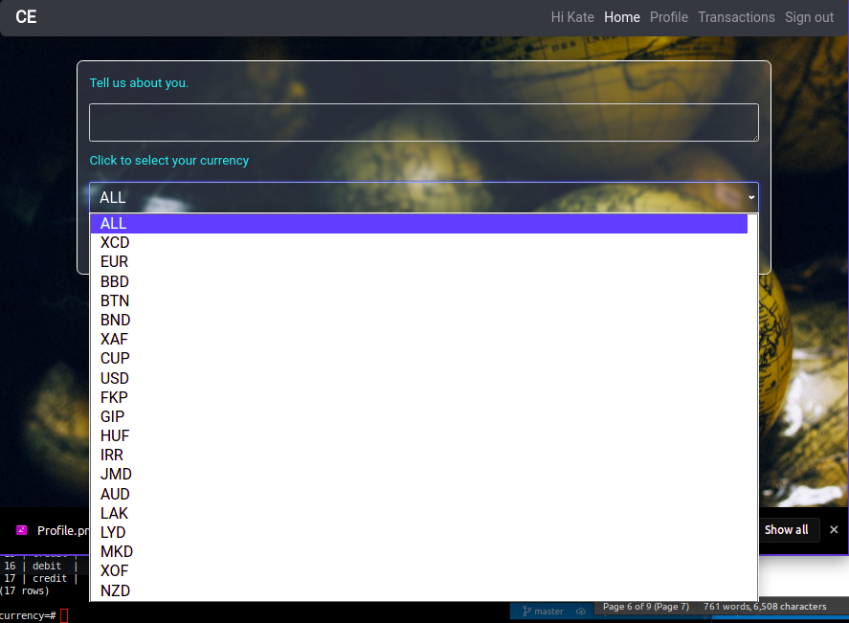
Database - Tables
List of relations
Schema | Name | Type | Owner
--------+-----------------+-------+-----------
public | alembic_version | table | deepeters
public | transactions | table | deepeters
public | users | table | deepeters
public | wallets | table | deepeters
(4 rows)
Sample Transactions Table
currency=# SELECT * FROM transactions;
id | type | amount | time | user_id | wallet_id
----+--------+--------+----------------------------+---------+-----------
1 | credit | 1000 | 2021-06-16 23:42:36.050322 | 1 | 1
2 | credit | 1000 | 2021-06-16 23:49:54.159081 | 2 | 2
3 | debit | 20000 | 2021-06-16 23:51:51.133788 | 2 | 2
4 | credit | 40000 | 2021-06-16 23:52:23.188492 | 2 | 2
5 | debit | 100 | 2021-06-16 23:52:49.632439 | 2 | 2
6 | credit | 10785 | 2021-06-16 23:52:50.777005 | 1 | 1
7 | credit | 1000 | 2021-06-16 23:55:41.480306 | 3 | 3
8 | debit | 100 | 2021-06-17 00:10:25.037367 | 3 | 3
9 | credit | 120 | 2021-06-17 00:10:25.984903 | 2 | 2
10 | debit | 15000 | 2021-06-17 00:10:53.475266 | 2 | 2
11 | credit | 12508 | 2021-06-17 00:10:54.097378 | 3 | 3
12 | credit | 1000 | 2021-06-17 00:12:56.846257 | 4 | 4
13 | credit | 1000 | 2021-06-17 00:14:44.236454 | 4 | 4
14 | credit | 2000 | 2021-06-17 00:14:58.460427 | 4 | 4
15 | credit | 1000 | 2021-06-17 19:30:01.284684 | 4 | 4
16 | debit | 50000 | 2021-06-17 19:30:49.947934 | 4 | 4
17 | credit | 50000 | 2021-06-17 19:30:50.636809 | 1 | 1
(17 rows)
Currency Conversion
A user can convert from one currency to the other on request using the “Make Conversion” function. Another way conversion happens is through transactions. For instance, when one user sends money to another user in the same app, in the case that their default currencies are different, conversion happens by default and reaches the receiver wallet in their default currency. The conversions are up to date with the conversion rates which update every hour. Debit and Credit functions can also be performed in any currency by a user to their own wallets and the money is saved to their wallets in their individual currencies.
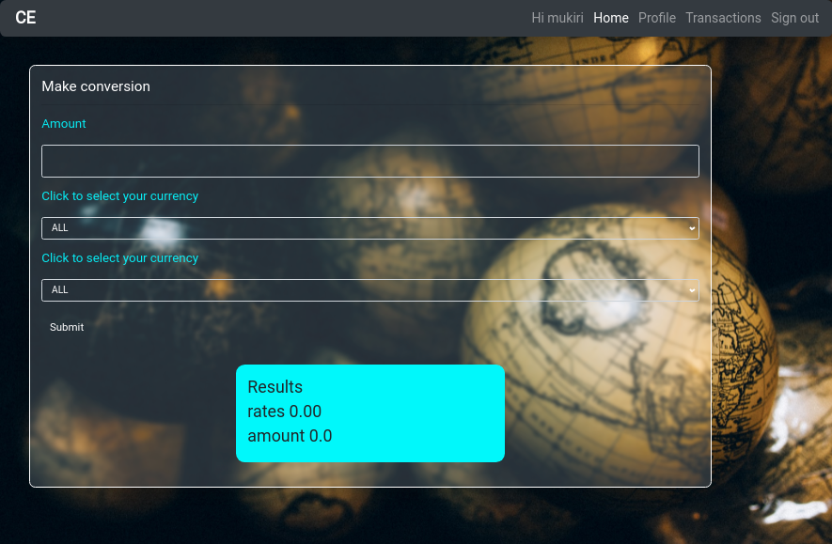
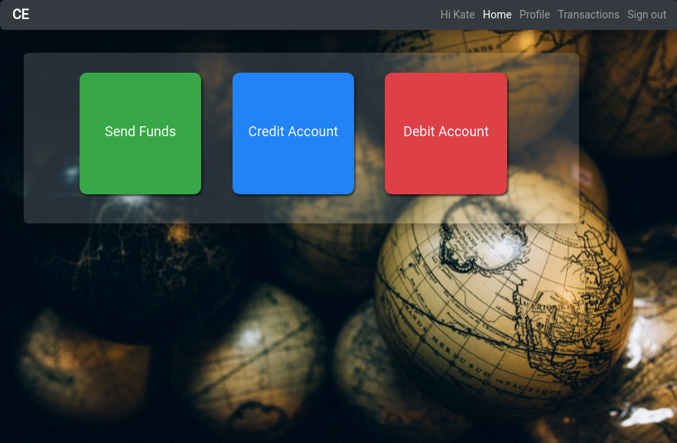
Transactions are displayed on the transactions page depending on the user where they can view debits and credits that occurred in their accounts as statement of accounts. Time and amount are also included in the report.
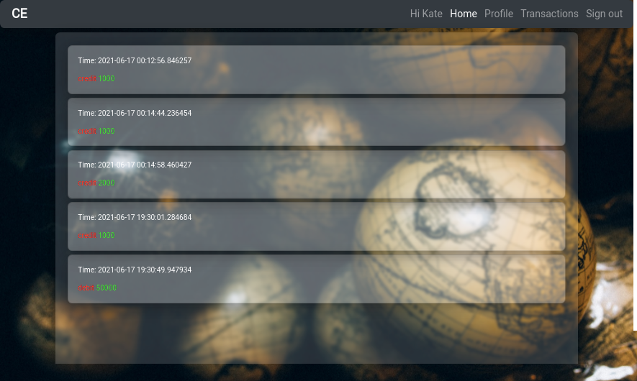
Suggestions as the App expands

